Email Campaign #1 (Send November 4th)

Dear Friends,

As you may know, I am involved with the work of The Northwest Catholic Counseling Center (NCC). Their mission is to serve all in need – regardless of ability to pay.

As the Holiday Season begins, I wanted to let you know they are launching their first Gifting Grace Campaign to lead up to and build momentum for Giving Tuesday on December 3rd. Giving Tuesday began in 2012, on the Tuesday after Thanksgiving. Following the material focus of Black Friday, Small Business Saturday, and Cyber Monday, it is a day dedicated to highlighting the important work nonprofits are doing in healthcare, education, housing, arts, etc. Last year, nonprofits raised $380 million on Giving Tuesday in the U.S. alone. As Giving Tuesday gains traction, nonprofits are hosting campaigns leading up to Giving Tuesday to expand support and raise awareness.

Throughout the month, I will be asking you to do two things.

First, help us raise awareness about the importance of mental health services in our community. According to Mental Health American, Oregon is ranked nearly last of all states in access to quality mental health care. We believe that mental health care is a right for all and not a privilege for only a few. Help us address the dire need for affordable mental health care in our community by sharing your own mental health story, destigmatizing mental health, and spreading the word to your friends and family about the importance of mental health care in our community.

Second, donate what you can. The reason no one is ever turned away from NCC because of an inability to pay is because of donors like you. The money we raise helps subsidize counseling for hundreds of our neighbors, like the waitress with debilitating bouts of depression, or the young woman recovering from a brutal rape – people who wouldn’t otherwise be able to access professional counseling. More than 1,200 people each year come to NCC for help and hope. Every client is eligible for sliding scale services, which goes as low as $5 for an appointment with a professional, experienced clinician.

Today, I challenge you to give up two pizzas this month and donate that money to a cause that matters. Join the #GiftingGraceChallenge by donating $20.19 here.

Together, we can change lives – one step at a time.

Gratefully,
(Your name here)

#GiftingGrace2019 #GivingTuesday2019 #PDXMentalHealth #GivingTuesdayforMentalHealth #NCCGivingTuesday2019

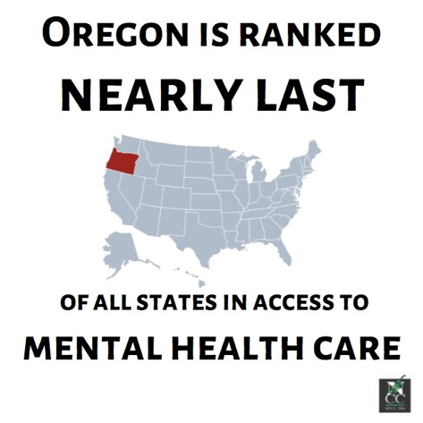

Email Campaign #2 (Send November 11th)

Dear Friends,

Today being Veterans Day reminds us of the many who have put their lives in harm’s way to keep us safe and secure. But when they come home, many veterans suffer post-traumatic stress disorder (PTSD), a mental health condition as a result of experiencing or witnessing a traumatic event. Those in the medical field state that while combat and combat-related military service can be traumatic, not everyone in those situations react the same way – some may develop PTSD symptoms and others may not.

Veterans and non-veterans alike experience PTSD – as well as other mental health issues. Did you know that one in five adults have experienced a mental health issue in their lifetime? Mental illness sure does not discriminate, and we believe care should not, either.

Thirty-three years ago, The Northwest Catholic Counseling Center (NCC) was founded by sisters of the Servants of Mary. With a passion for social justice, they opened the doors of NCC grounded in the belief that health care is a basic right for all people. To celebrate 33 years of NCC providing life-changing mental health services to all in need, I challenge you to donate $33 to the Gifting Grace Campaign.

With your help, we can change the way Portland views mental health – and provide a safe space for people in need of affordable care can receive the mental health services they deserve.

Gratefully,
(your name here)

#GiftingGrace2019 #GivingTuesday2019 #PDXMentalHealth #GivingTuesdayforMentalHealth #NCCGivingTuesday2019

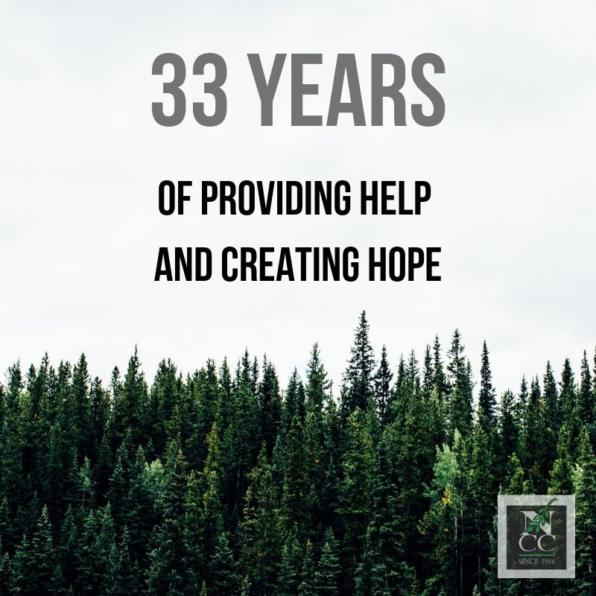
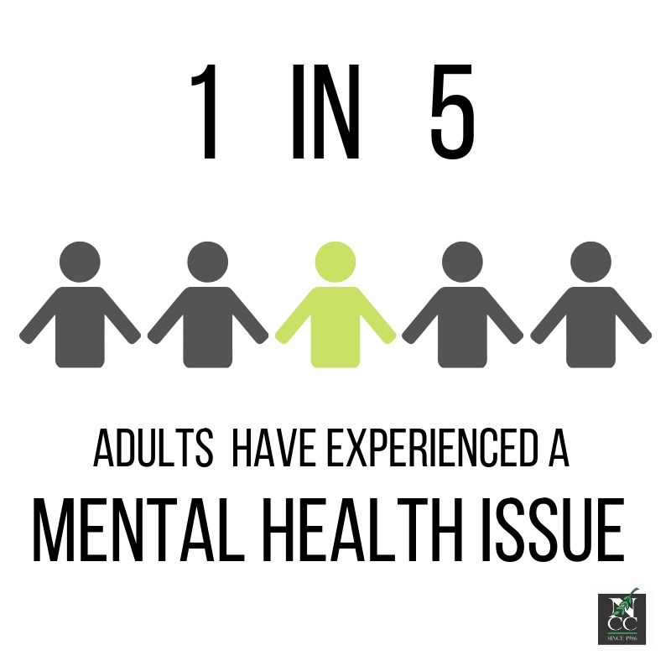

Email Campaign #3 (Send November 18th)

Dear Friends,

According to Mental Health America, one in ten young people have experienced major depression. Our youth face many challenges, particularly with their mental health. But when teens like Molly find their way to The Northwest Catholic Counseling Center, they find hope and healing.

Sixteen-year-old Molly had perfect grades, was involved in art classes, and had supportive friends and family. But having set sky-high standards for herself, she had crippling anxiety. She sometimes thought about suicide, which scared her, so Molly made her way to NCC. She and her therapist tried to connect by talking through her emotions, but her mind wandered and she had trouble focusing. Her therapist knew Molly enjoyed art – so they began processing her emotions using drawing. Having an avenue to express herself, Molly felt more empowered and less anxious. When she completed treatment, Molly left this voicemail for her therapist: Thank you for helping me realize the value I have to offer in the world.

Today I challenge you to give up a night out at the movies and donate that money to help teens like Molly through the Gifting Grace Campaign.

Teens face enough challenges just being teenagers. Help normalize mental health issues so teens feel comfortable asking for help – and help us provide a comforting space for them.

Gratefully,
(your name here)

#GiftingGrace2019 #GivingTuesday2019 #PDXMentalHealth #GivingTuesdayforMentalHealth #NCCGivingTuesday2019

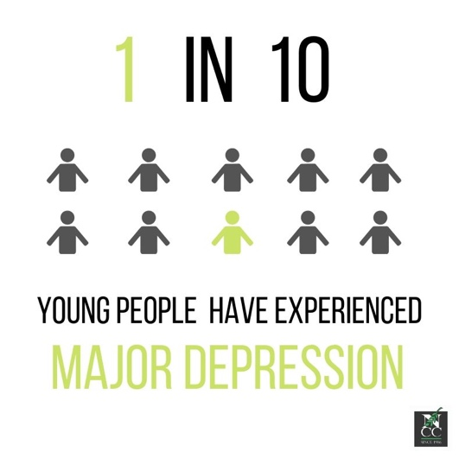

Email Campaign #4 (Send November 25th)

Dear Friends,

Limited financial resources prevent many from getting mental health care. For this reason, among others, 33% of people screened for depression do not seek treatment. So many people come through our doors because they have nowhere else to turn – particularly women. The Northwest Catholic Counseling Center (NCC) makes a special commitment to serve women and children, who often shoulder the greatest social and economic burdens of poverty and mental health issues.

Janelle is an example of someone who has benefited from our services. Janelle came to NCC with a myriad of losses: her moth, uncle, friend, and cat, all in the last year. Having been a nurse for the last 18 years, the weight of her work burdened her, and she had recently been put on medical leave due to an injury. Janelle came to NCC to work through her grief and sadness. Being in her fifties, she felt loss around things she’d likely never accomplish: getting a master’s degree, getting married, having kids. Janelle’s therapist gave her “homework” assignments to help her identify activities that would bring her joy. She tried a few things – cooking, gardening, exercising, reading. Not everything stuck, but those that did gave her ownership over her time. Janelle reframed her life into what she could still do rather than focus on what she lost. Recognizing her strengths and her value, she gathered up enough courage to leave her stressful job – and told her therapist she has never been happier.

Janelle rose above the 33% and came to NCC for help and hope. To support the 33% of people screened for depression but have not been treated yet, I urge you to donate $33 to NCC today.

Mental health issues are often unseen or ignored. Shed a light on mental health by telling our stories or your own. It’s only by talking about mental that we can destigmatize it.

Gratefully,
(your name here)

#GiftingGrace2019 #GivingTuesday2019 #PDXMentalHealth #GivingTuesdayforMentalHealth #NCCGivingTuesday2019

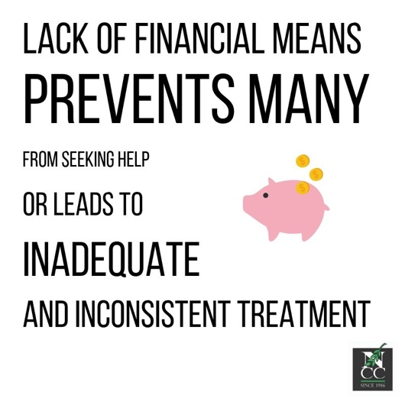
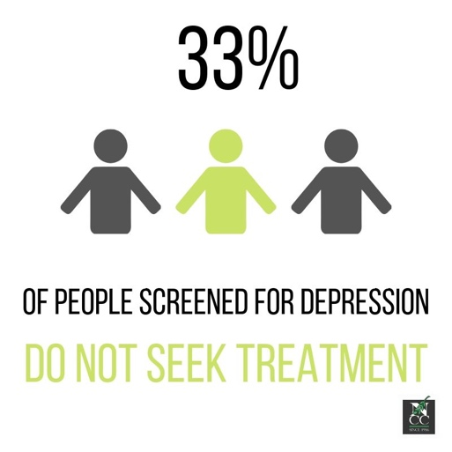

Email Campaign #5 (Send December 3rd – Giving Tuesday)

Dear Friends,

Today’s the day! Giving Tuesday 2019.

I’m asking for you to support The Northwest Catholic Counseling Center (NCC) – an organization providing critical value to our community in Portland.

Any contribution you’re able to make would go far and help individuals like Juan. Having grown up very poor in Mexico, Juan moved to Portland to provide a better life for himself and his family. Achieving a Master’s degree, employment, and even owning property, Juan seemed to have made it. But with the magnified anti-immigrant rhetoric and hate speech, Juan began having panic attacks – fearing at any moment, he might be deported. To reframe his fixations, Juan’s therapist encouraged him to try meditation. Exhaling fear and anxiety. Inhaling calm and peace. As Juan began practicing, he gradually quieted his anxious mind. Over the months, Juan improved. He recently sent a note to his therapist: Thank you for helping me realize the power of my own mindset. Without my constant panic attacks, I applied to a new job – and got it!

I urge you to make a financial contribution to NCC – one of the only organizations in Portland providing mental health services on a sliding scale fee. Click here to donate today!

Gratefully,
(your name here)

#GiftingGrace2019 #GivingTuesday2019 #PDXMentalHealth #GivingTuesdayforMentalHealth #NCCGivingTuesday2019

